Our mission is to excel in the manufacture, Supply and Installation of the best quality, safest and aesthetically.
Creating customized Cold Room, Clean Room, Blast Chiller &Freezer Room, Banana Ripening Chamber, Incubation Chamber, Clean room Door, Cold Room Door, Sliding Door, Hatch Door, Electrical Control Panel & Tube Ice Machine and Supplying Evaporator Unit for Cold & Freezer Room, Condensing Unit for Cold & Freezer Room, Water Chiller, PUF Panel, Roof Panel & Floor Slab.
Perfect Cooling System
Add.: Nishita Niwas Building H. No. 289/5, Opp. Adivasi ashram school,
At. Po. Khadavali (W). Tal. Kalyan, Thane - 421 301.
Mob.: 9637996333Email: kppcs2017@gmail.com
Perfect Cooling System
Company Profile
Regarded as forerunners of the domain we Perfect Cooling System are efficiently carrying the responsibility of meeting the major share of market demand of Commercial Freezers and Other Cooling Solutions by functioning with utmost dedication as Service Providers, Suppliers and Traders of a complete gamut of
Products. We have lucratively carved a niche for ourselves in the domain by offering products like Cold Room Unit, Blast Freezer, bulk Cooler, Clean Room, Tube Ice Machine and Flake Ice Machine, etc. Also, our ability to render customer oriented services like maintenance, sales support, etc have acted as major catalyst in our radical growth. Each and every element of our product line is tried and tested to be at par with international variants in terms of quality, price and functionality.
Additionally, we have occupied a wide facility in Mumbai, Maharashtra, India for effective management of our large inventory turnover ratio which is a function of our national wide fame. This facility renders immense support for attuning our supply with market demand as it abides us in easy storage and extraction of sourced range. We always ensure to far exceed our patrons expectations by offering them with unmatched value.

Nature of Business
Service Provider, Supplier & Trader,

Year of Establishment
2017
PUF Panel, Roof Panel, & PUF Slab

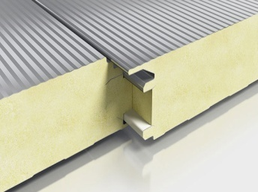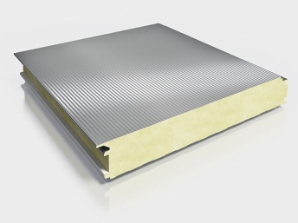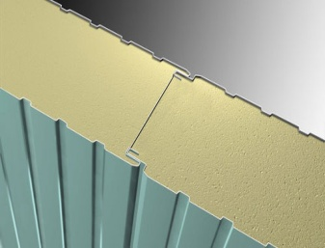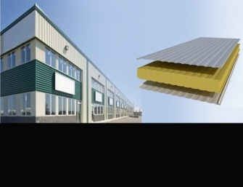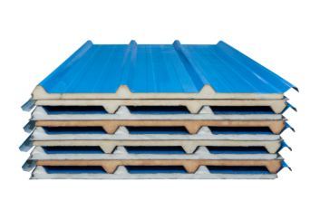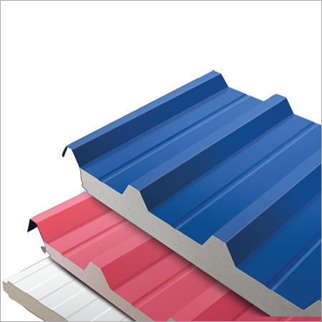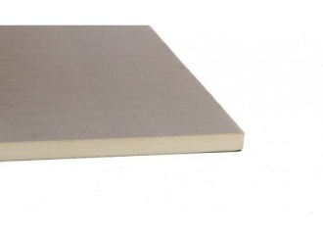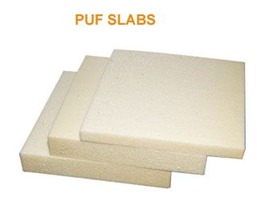
Pre-fabricated, insulated, metal laminated panels best suited for freezing and chilling
• Rigid polyurethane Foam (RPUF) insulation
• Pre-painted Galvanized Steel (PPGS) or Stainless Steel (SS) metal laminate
• Insulation thickness from 30 mm up to 200mm
• Panel width of 1000 mm
• Joinery through cam lock and finished with a siliconesealant

Doors ( Clean Room Door, Cold Room Door, Sliding Door & Hatch Door )
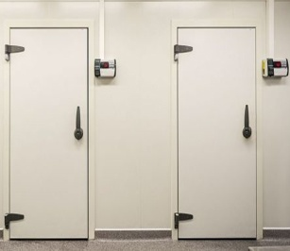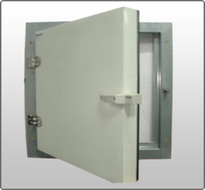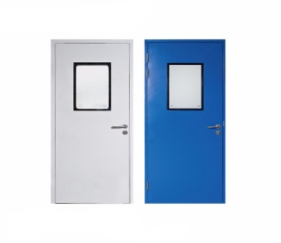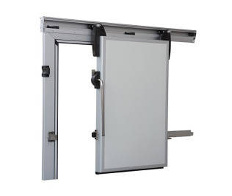

Pre-fabricated, insulated doors with great features
• Swing, sliding, roll-up types
• Non-corrosive, non-metallic hinges, door handles, and locks
• Self-closing hinges
• Heaters in door leaf and frame
• Audio alarm for 'door-open' condition
• View port with anti-condensate glass
• Lock defeat mechanism
• Positive seal mechanism for all door types to avoid cold air loss
Specially-cold rooms, Cold Storage for special applications
• High humidity cold rooms, Cold Storage for fruit and vegetable storage
• Low humidity cold rooms, Cold Storage for seed and hygroscopic material storage
• Humidification and automation systems
• Unique design for generating low humidity environment using specially designed
Refrigeration systems
Clean Room

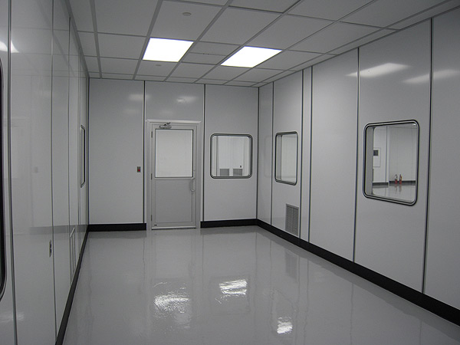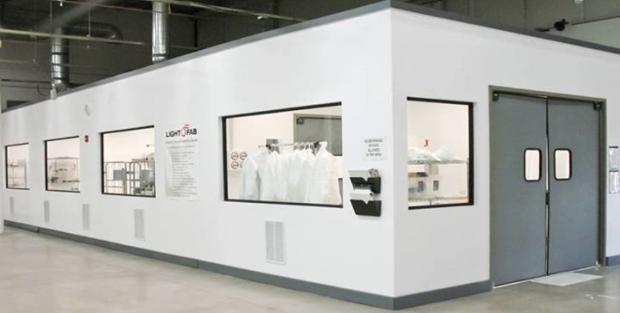

INSULATED PANELS FOR CLEAN ROOM
BUILDING-INSTABUILD HYPER CLEAN (EBP)

RIGID POLY URETHANE /POLY ISOCYNURATE FOAM INSULATED
PANELS SUITABLE FOR BUILDING CONSTRUCTION APPLICATION,
WITH THICKNESS 50-150mm. STANDARD LAMINATION - PCGI. WITH EDGE PROFILE
Clean rooms are designed to maintain extremely low levels of particulates, such as dust, airborne organisms, or vaporized particles.

Cold Storage Room / Cold Room

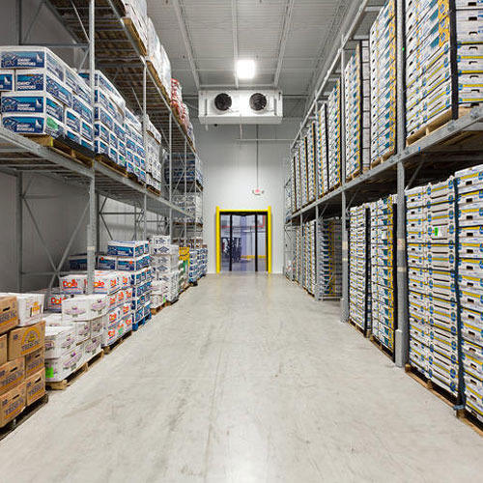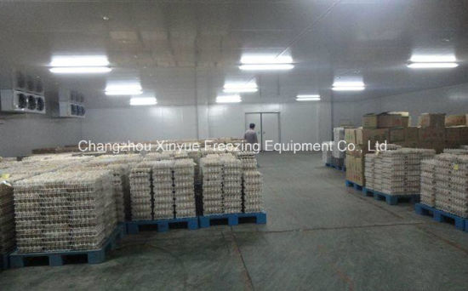

We are a renowned supplier of an excellent range of Cold Room. This also includes Room Air Conditioners, Cold Storage Room and Modular Cold Room. Widely used in food & beverage, pharmaceutical and cosmetic industry, these are specifically engineered to preserve the products at a specific temperature. We offer our entire range to clients in varied specifications to meet their exact needs.
A cool store or cold store is a large refrigerated room or building designed for storage of goods in an environment below the outdoor temperature. Products needing refrigeration include fruit, vegetables, seafood and meat. Cold stores are often located near shipping ports used for import/export of produce
Banana Ripening Chambers

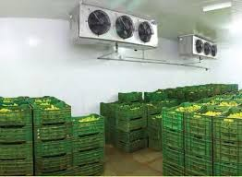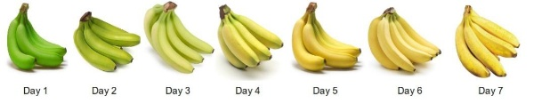

Engineered to simulate nature's ripening process without altering the taste or Freshness. PCS Pioneered the indigenous, pressurized type Banana Ripening chambers of global standard which is running exceptionally well all over India. With expertise across the full spectrum of fruit Banana ripening chambers, Pre-cooling chambers, cold storage construction & refrigeration system, PCS provides focused solutions namely conceptualizing, designing, manufacturing and implementation of cold infrastructure requirements to cater to need of diverse industries. PCS offers Banana ripening chambers available with Pressurized/Reverse air flow evaporators and Humidity controlled rooms.

INCUBATION CHAMBERS

Standard Incubation time is approx. 4 hours but it will depend upon the packing type and loading temperature of curd with a condition that the chamber temperature should be 45° C before loading. Standard cooling time is approx. 5 hours but it will depend upon the packing type and loading temperature of curd with a condition that timing will be considered after getting chamber temperature as 2° C.

Blast Chiller & Freezer Room

Features

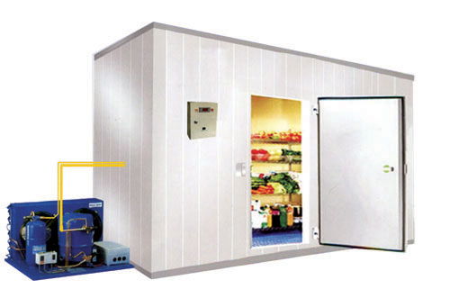
- Application: Multi-Door Design is effective when freezing or hardening of product is done with storage in crates and trolley.
- Product: Ice Cream, Meat, Ready to Cook & Ready to Eat Food.
- Temperature: -25°C to -40°C
- Capacity: 200 Kg to 2000 Kg

REFRIGERATION SYSTEMS

Freon Based Refrigeration Systems
• Air/water Cooled Hermetic/semi-hermetic /screw/ scroll R404a Refrigerant Systems For Cold Storages
• Low Humidity Refrigeration Systems for Seed Storages
• High Humidity Refrigeration Systems
• Ultra Low Temperature Refrigeration Systems For Blast/tunnel/plate/spiral Freezers
• Bulk Milk Chillers
• Water/brine Chillers For Milk Chilling And Other Processes
• Special Refrigeration Systems For Stability Chambers
• Special Refrigeration Systems For Ripening Chambers
• CA Chamber

Ammonia Based Refrigeration Systems
• Refrigeration Systems For Cold Storages
• Ultra Low Temperature Refrigeration Systems For Blast/tunnel /plate Freezers
• Iqf For Peas /fish/rte Etc..
• Spiral Freezers For Meat/rte/f&v Etc..
• Water/brine Chillers For Milk Chilling And Other Processes
• Compressor Packages With Open/recip/screw Compressors Suitable For Any
Applications - Compak
• Water Cooled/evaporative Condensing Unit For All The Capacities - Conspak
• Low Pressure Receiver With Controls – Freezolator
